**Mobile Environment Configuration**

1. **Install Git**

Download Git for Windows from here: "​<https://git-scm.com/download/win>".​

Install as Administrator using​​ all the default settings.​

Configurate environment:

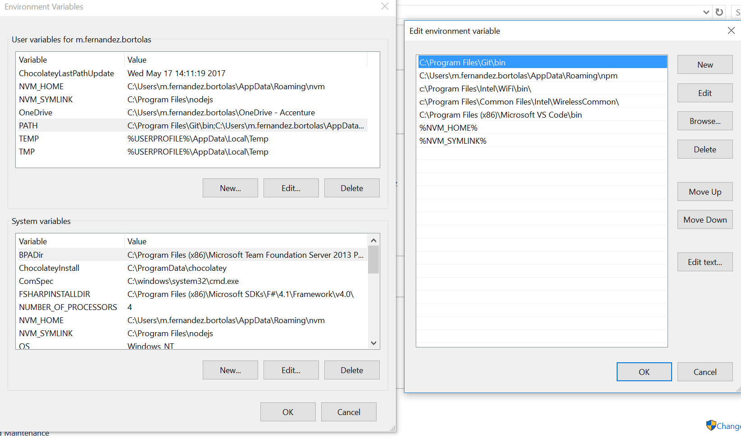

1. **Install Visual Studio Code**

Download Visual Studio Code from here: "<https://code.visualstudio.com/Download>".

Install as Administrator using all the default settings.

1. **Install the Java JDK**

Download Java JDK(latest version) from here: <http://www.oracle.com/technetwork/java/javase/downloads/jdk8-downloads-2133151.html?ssSourceSiteId=otnes>

1. **Install the Android Studio**

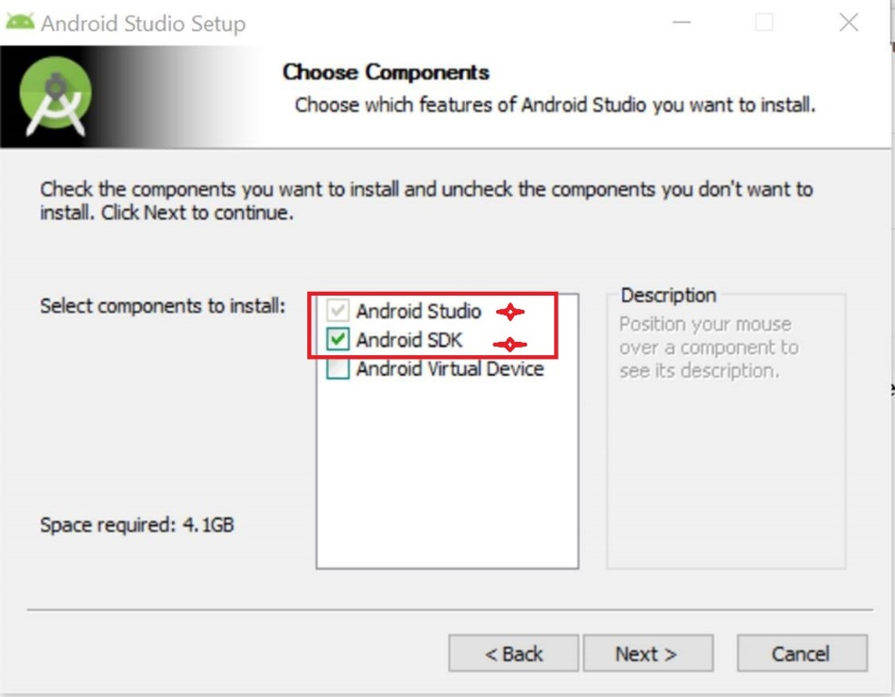

Then click Next> until finish.

1. **Install Android SDK(need VPN)**

Open your local path (like “C:\Users\EID\AppData\Local\Android\android-sdk\SDK Manager.exe”.) find SDK Manager.exe. (if you install for all users it will be on program files folder)

Download follow showing packages(need the same version or EtherTalk)

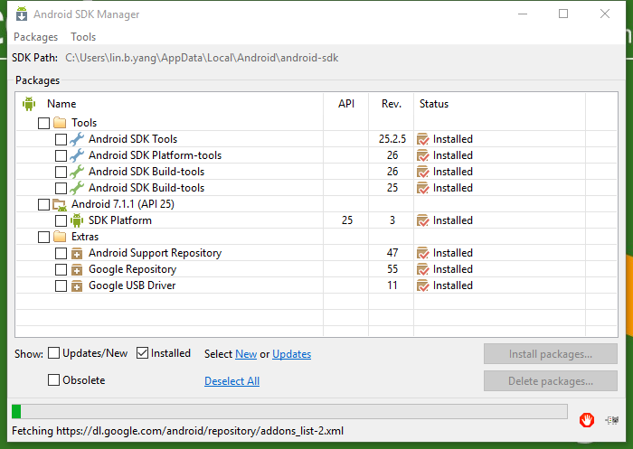

1. **Configurate environment variables**

Make sure that the "**JAVA_HOME**" environment variables pointing to the new version of the JDK (C:\Program Files\Java\jdk1.8.0_60)

Make sure that the "**ANDROID_HOME**" environment variable is pointing to the new version of ANDROID  (C:\Program Files (x86)\Android\android-sdk)

Make sure that the Android_Home is included into **Path** environment variable. Add new value %ANDROID_HOME%\tools;%ANDROID_HOME%\platform-tools

1. **Install Node.js(node-v6.11.5-x64) (need VPN)**

Download Node.js **version 6.11.5** from here [https://nodejs.org/dist/v6.11.5/node-v6.11.5-x64.msi​](https://nodejs.org/dist/v6.11.5/node-v6.11.5-x64.msi)

Run these in cmd:

npm install -g cordova

npm install -g typescript@latest

**Create a new Cordova Project**

1. **Create a Cordova project**

create hello com.example.hello HelloWorld

1. **Open this project by Visual Studio Code(need VPN)**

Run below in VS Code:

npm install

cordova platform add ios –save

cordova platform add android –save

1. **Build App**

cordova requirements

cordova build (cordova build ios/cordova build android)

**Run MyTE Mobile App**

1. **Install Allow-Control-Allow-Origin plugin on Chrome(need VPN)**

Download Allow-Control-Allow-Origin from here: "<https://goo.gl/xddjsS>"

1. **Download the solution**

Open Microsoft Visual Studio ​and get the latest version of the solution "$/myTEWebCode_Project/myTEMobileApp/trunk"

1. **Configure VS Code**

Open the solution by VS Code

Install the Node Packages with this command: npm install

execute the Application with this command: npm run ionic:serve

**Common Issues:**

1. If you have the issue "Error: Missing binding ..\trunk\node_modules\nose-sass\vendor\win32-x64-48\binding.node", run the command **"npm rebuild node-sass"**
2. If you have the issue “UNMET PEER DEPENDENCY”， it means npm version is not the latest version, we can ignore it.
3. If you have the issue "Error: Cannot Connect/Download https://github.com/sass/node-sass/releases/download/v3.13.0/ [win32-x64-51_binding.pdb](https://github.com/sass/node-sass/releases/download/v3.13.0/win32-x64-51_binding.pdb)". Firstly make sure you have connected with the VPN. Then try it again until successfully.